ItemMaster Fast Maintenance Overview & Flow

When the user executes Fast Item Master Maintenance from the Inventory Maintenance Menu they first must choose to download a file or upload changes.

Choosing download, the user is presented with a prompt/filter page similar to that of the Selected SKU Report (including both Start & End Setup Date which may require scrolling).

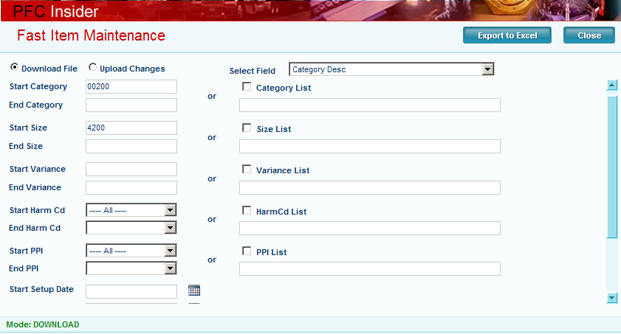

The only thing that is truly required is to select the field to maintain (I selected the category description). Please note that the larger the range selection is, the longer it will take the system to download (and upload) the information (I selected all category 00200 with size 4200).

Clicking the Export To Excel button opens the export window and the user should encounter the File Download dialogue. Notice that the program creates a unique file name based on the program, user ID & user name plus the field being maintained. Users should save the file to their own My Documents location to access it for maintenance and upload.

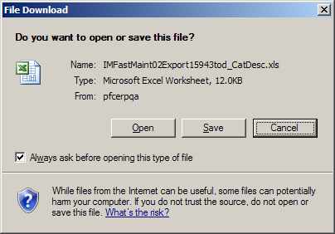
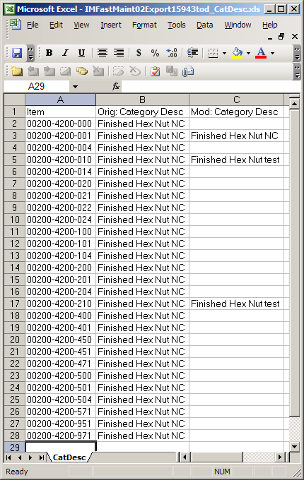
The downloaded file will look like this. Notice the name of the worksheet tab is “CatDesc” in this example. This is important! The worksheet tab name will ALWAYS reflect the name of the field being maintained. This is REQUIRED for the program to work properly. Other than that, this is a standard Excel worksheet. Users may sort the data or remove rows normally.

Notice the 3 changes that I made in column ‘C’. When I upload this file for processing only the 010 & 210 items will be updated. The program filters out all rows where column ‘C’ is empty or where columns ‘B’ and ‘C’ are equal.

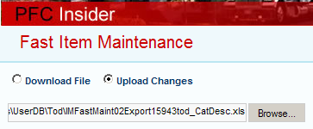
Once the changes are entered into the spreadsheet and saved, the user must upload the changes. The program uses the standard Windows browse function to allow the user to locate and choose a file.

Once the file has been selected, the user clicks the Submit button and the file is uploaded for processing (see below for technical details).

If there are exceptions encountered during the update, they will be emailed to the user; otherwise, the user will receive a success message from the process.

